Nearly a quarter of a million American will be diagnosed with lung cancer this year, or one every two and a half minutes. It is the leading cancer killer in the United States, accounting for about one in four cancer deaths. The five-year survival rate for lung cancer is only less than one in five (18.1%), much lower than those for many other common cancers. Less than half of those diagnosed with lung cancer will still be alive a year later. Lung cancer can be prevented, and new research has shown that screening can catch more cases earlier and save lives.

However, the burden of lung cancer is not the same everywhere. Some states have much higher rates of new cases than others, or much lower survival rates. Treatment, exposure to risk factors, and access to screening facilities also varies from state to state.

This report summarizes the available data on state-specific lung cancer burden. It provides policy makers, researchers, health care practitioners, and anyone committed to ending lung cancer with a one-stop resource for identifying where their state can best focus its resources to decrease the burden of lung cancer.

Connecticut

**Prevention**

***Tobacco*** use is the leading risk factor for lung cancer. Smoking and second-hand smoke have both been shown to cause lung cancer. 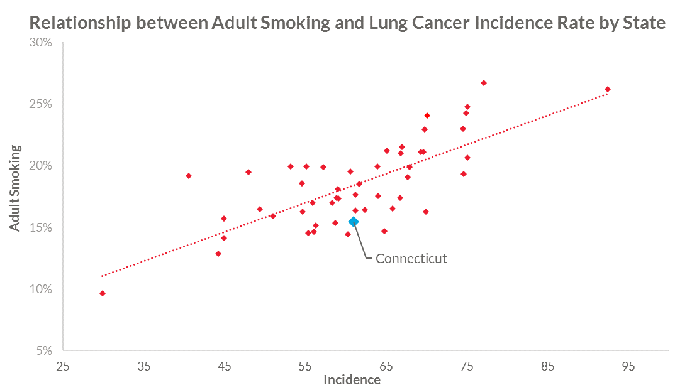



For each one point increase in the smoking rate for a state, the lung cancer incidence rate increases 2.4 points

* The smoking rate in Connecticut is 13.5%, lower than the national average of 16.8%.
* Each year the American Lung Association puts out The ["State of Tobacco Control"](http://www.lung.org/assets/documents/tobacco/state-of-tobacco-control.pdf) report. The 2017 report grades all fifty states and the federal government on four key tobacco control policies: tobacco control and prevention spending, smokefree air, tobacco taxes, and cessation coverage. Connecticut’s 2017 State of Tobacco Control report grade are:
  + "F"  for Tobacco Prevention Program Funding;
  + "C" for Smokefree Air;
  + "B" for Tobacco Taxes;
  + "D" for Access to Tobacco Cessation Treatments; and
  + "F" for Tobacco 21 Laws.

*For more resources on quitting smoking, visit Lung.org/stop-smoking*

The dotted line in the chart shows that, on average, each one point increase in the smoking rate for a state equals an increase of 2.4 points in the lung cancer incidence (the number of new lung cancer cases) rate. For Connecticut, not only is the smoking rate below the national average, but the lung cancer incidence rate is higher than would be expected for this smoking rate, as shown by the Connecticut data point being below the dotted line in the chart. This suggests that people living in Connecticut might have higher exposures to other risk factors besides smoking.

***Radon*** is the second leading cause of lung cancer. Radon is a colorless and odorless can seep into homes and buildings. Some geographical areas have naturally higher radon rates than others. The US EPA has set an action level of 4 pCi/L. At or above this level of radon, the EPA recommends you take corrective measures to reduce your exposure to radon gas.

* 41 Counties in Connecticut are considered Zone 1 which means they have predicted average indoor radon screening levels greater than 4 pCi/L.
* 22 counties in Connecticut are considered Zone 2 which means they have a predicted average indoor radon screening levels from 2 to 4 pCi/L

*For more information on radon testing and removal, visit Lung.org/radon*

***Air Pollution*** is a known risk factor of lung cancer.

* Each year the American Lung Association puts out the “State of the Air 2017” report. The 2017 report grades U.S. counties on harmful ozone (smog) and particle pollution recorded over a three-year period, and details trends for metropolitan areas over the past decade. The report ranks also both the cleanest and most polluted areas in the country. [View the Connecticut report card.](http://www.lung.org/our-initiatives/healthy-air/sota/city-rankings/states/connecticut/)

*For more information about air pollution, visit Lung.org/healthy-air*

Learn more about the [other risk factors](http://www.lung.org/lung-health-and-diseases/lung-disease-lookup/lung-cancer/learn-about-lung-cancer/what-is-lung-cancer/what-causes-lung-cancer.html) for lung cancer and [how you can reduce your risk](http://www.lung.org/lung-health-and-diseases/lung-disease-lookup/lung-cancer/learn-about-lung-cancer/how-do-i-reduce-my-risk/).

**Early Detection**

**Lung cancer screening using low-dose CT scan is recommended for those who meet the high-risk criteria:**

* 55-80 years of age
* Have a 30 pack-year history of smoking (this means 1 pack a day for 30 years, 2 packs a day for 15 years, etc.)
* AND, are a current smoker, or have quit within the last 15 years

Screening for lung cancer with annual low-dose CT scans among those at high risk can reduce the lung cancer death rate by up to 20% by detecting tumors at early stages when it is more curable. For screening to be most effective, patients must be able to access high-quality centers offering the service, such as those accredited by the American College of Radiology. Patients may benefit from a greater number of accredited centers in their state as can improve the chances of a center being nearby and their ability to get screened.

**Lung cancer by the numbers**

Connecticut ranked 3rd among all states with 9.5 accredited lung cancer screening centers per million people, much better than the national rate of 4.8 centers per million people. This shows there are a high number of screening centers throughout the state available to the high-risk population in Connecticut. This increases the likelihood that an individual would have access to a screening center nearby and reduces a barrier to lung cancer screening.

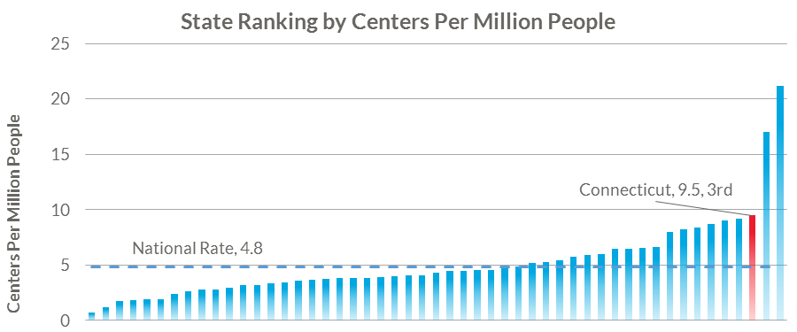



**Lung Cancer Rates**

**Incidence**

Incidence is the number of new lung cancer cases diagnosed each year. The incidence rate in Connecticut is 61.0, about the same as the national rate of 60.4, and 25th best among all states.





**5 Year Survival Rate**



The percent of people still alive five years after being diagnosed with lung cancer (the survival rate) in Connecticut is 22.4%, higher than the national rate of 17.8%, and 10th best among all states.

**Stage at diagnosis**

Most lung cancer cases are diagnosed at later stages when the cancer has spread to other organs, treatment options are more limited, and survival is lower.

In Connecticut, only 22% of cases are caught early when survival is a much higher (66%). Unfortunately, most cases (51%) are not caught until a late stage when survival is only 5%.

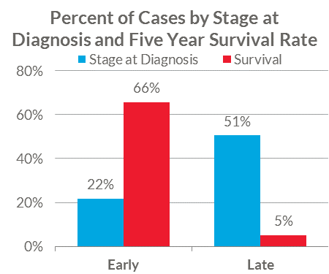



**Surgical Treatment**

Lung cancer can often be treated with surgery as part of the first course of treatment if it is at an early stage and has not spread outside of the lung and lymph nodes close to the lung. While surgery may not be an option for every patient, those who receive it as part of their initial treatment have higher survival rates than those who do not. Patients who are not healthy enough to undergo the procedure or whose cancer has spread too far may not be candidates for surgery. Other treatments may be recommended instead or in addition to surgery, such as chemotherapy, radiation, targeted therapy, or immunotherapy.

Connecticut had the 2nd best rate (out of the 48 states with data available) with 27.4% of cases undergoing surgery as part of the first course of treatment, a higher rate than nationally (21.0%).

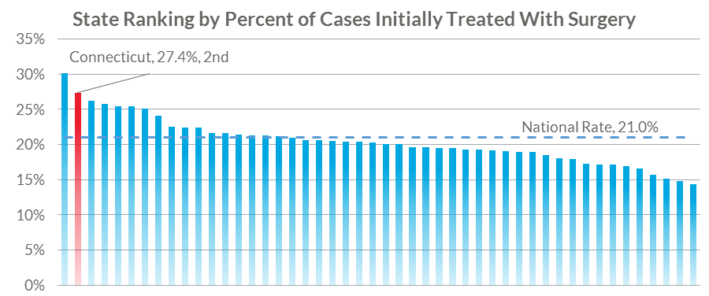



**Summary**

Despite having a below average smoking rate, Connecticut has a lung cancer incidence rate similar to average. However, the state also has more screening centers per population than average, which could contribute to having both the second best rate of surgery during the initial round of treatment and a better than average survival rate.

Connecticut residents can lower their risk of being diagnosed with lung cancer, as well as the risk of those around them, through these steps:

* Quit smoking, or don’t start.
  + If you or someone you know is ready to quit smoking, the American Lung Association is here to help. Our [Freedom From Smoking](http://www.lung.org/ffs) program has helped over a million people quit smoking for good.
  + Higher tobacco taxes both encourage people to quit and prevent children and others from starting to smoke.
  + Well-funded tobacco control programs are an important part of helping people quit and keeping potential new smokers from starting.
  + [Full coverage](http://www.lung.org/cessationcoverage) for all FDA-approved smoking cessation methods, with no barriers to accessing them, leads to more successful quit attempts.
* Make your house and car smokefree air zones, with no smoking allowed. Avoid places that are not smokefree, and advocate for smokefree air policies in restaurants, bars, casinos, or anywhere they are not in place.
* Check your house for radon, and learn what to do if levels are too high.
* Reduce your exposure to unhealthy outdoor air.
  + Stay indoors on unhealthy air days.
  + Support clean air policies, including no idling zones and emissions limits.

Maintaining a high number of quality, accredited screening centers will help ensure that both as many patients undergo surgery during their initial round of treatment and as high a survival rate as possible.